LAW I - THE PLAYING COURT
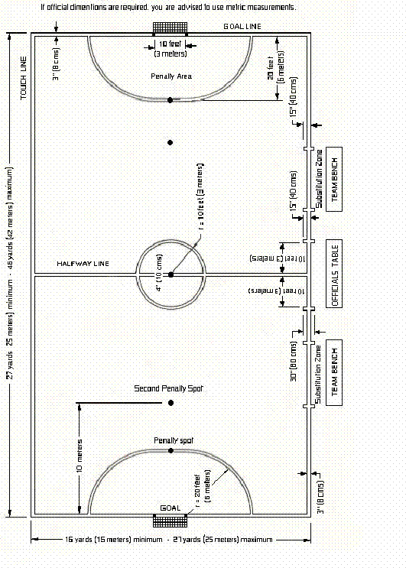

LAW II - The Ball
• Size #4
• Circumference: 62-64 cm
• Weight: 390-430 grams
• Bounce: 55-65 cm on first bounce
• Material: Leather or other suitable material (i.e., not dangerous)
LAW III - Number of Players

• Minimum Number of Players to Start Match: 6, one of whom shall be a goalkeeper
• Minimum Number of Players to Finish Match: 3
• Maximum Number of Substitutes: NO LIMIIT
• Substitution Limit: None
• Substitution Method: "Flying substitution" (all players but the goalkeeper enter and
• leave as they please; goalkeeper substitutions can only be made when the ball is out of play and with a referee's consent)
LAW IV - Players' Equipment
Usual Equipment: socks, protective shin-guards and footwear with rubber soles
LAW V - Main Referee

• Duties: Enforce the laws, apply the advantage rule, keep a record of all incidents before, during and after game, stop game when deemed necessary, caution or expel players guilty of misconduct, violent conduct or other ungentlemanly behavior, allow no others to enter the pitch, stop game to have injured players removed, signal for game to be restarted after every stoppage, decide that the ball meets with the stipulated requirements.
• Position: The side opposite to the player benches
• Power Unique to Main Referee: Can overrule Assistant Referee's calls.
LAW VI - Timekeeper
• Duties: Start game clock after kick-off, stop it when the ball is out of play, and restart it after all restarts; keep a check on 2-minute
punishment for sending off; indicate end of first half and match with some sort of sound; record time-outs and fouls (and indicate
when a team has exceeded the 5-foul limit); record game stoppages, scorers, players cautioned and sent off, and other
information relevant to the game.
• Position: Outside halfway line on the same side as the substitution zone (i.e., the players' bench side)

LAW VII - Duration of the Game

• Duration: Two equal periods of 20 minutes; clock stopped whenever ball is out of play. Time can be prolonged only to take a penalty kick.
• Time-outs: 1 per team per half; none in extra time
• Half-time: Maximum of 15 minutes
LAW VIII - The Start of Play
Procedure: Coin toss followed by kickoff; opposing team waits outside center circle; ball deemed in play once it has been touched; the
kicker shall not touch ball before someone else touches it; ensuing kick-offs taken after goals scored and at start of second half.
LAW IX - Ball in and out of Play

• Ball out of play: When it has wholly crossed the goal line or touchline; when the game has been stopped by a referee; when the ball
hits the ceiling (restart: kick-in at the place closest to where the ball touched the ceiling).
• Lines: Touchlines and goal lines are considered inside the playing area.

LAW X - Method of Scoring
When the whole of the ball has passed over the goal line, between the goal posts and under the crossbar (except by illegal means).
LAW XI - Fouls and Misconduct
Direct free kick awarded when a player intentionally commits any of the following 11 offenses (penalty kick awarded when infringement
takes place in penalty area)
• kicking or attempting to kick an opponent
• tripping an opponent
• jumping at an opponent
• charging an opponent in a violent or dangerous manner
• charging an opponent from behind
• striking, attempting to strike, or spitting at an opponent
• holding an opponent
• pushing an opponent
• charging an opponent with shoulder (i.e., shoulder charge)
• sliding at an opponent (i.e., sliding tackle)
• handling the ball (except goalkeeper)
Indirect free kick awarded when any of the following 8 offenses is committed (kick taken from the 6-meter line when infringement takes
place in penalty area):
• dangerous play (e.g. attempting to kick ball held by goalkeeper)
• obstruction
• charging the goalkeeper in the penalty area (i.e., goalkeeper charge)
• goalkeeper throws ball directly over the halfway-line (without it first touching his own side of the pitch or any player)
• goalkeeper picks up or touches with his hands a back pass
• goalkeeper picks up or touches with his hands a kick-in from a teammate
• goalkeeper controls the ball with any part of his body for more than 4 seconds
• goalkeeper touches with any part of his body a back pass that has been played back to him before the ball has (1) crossed the
halfway-line or (2) been touched by an opponent
Players shall be cautioned (i.e., shown yellow card) when:
• a substituting player enters the pitch from an incorrect position or before the player he is substituting has entirely left the pitch
• he persistently infringes the Laws of the Game
• he shows dissent with any decision of the referee
• he is guilty of ungentlemanly conduct
These 4 yellow-card offenses are punishable by an indirect free kick taken from the point of infringement (or from the 6-meter line
when the infringement takes place in penalty area).
Players shall be sent off (i.e., shown the red card) for:
· (a) serious foul play
· (b) violent conduct
· (c) foul or abusive language
· (d) second instance of cautionable offense (i.e., second yellow card)
· (e) intentionally impeding a clear goal opportunity (e.g. through a "professional foul")
· (f) intentionally impeding a clear goal opportunity in the penalty area by handling the ball
Direct free kicks (or penalty kicks) accompany the expulsion for (a), (b), (e) and (f); indirect free kicks, for (c) and (d) (from the 6-meter line
when the infringement takes place in the penalty area).

Rules of Expulsion:
• The player sent off (shown a red card) is out for the rest of the game and is not even permitted to sit on the reserves' bench.
• The team of the player sent off can substitute for that player after 2 minutes of playing time or after the opposing team scores --
which ever comes first.
• The 2-minute punishment shall be checked by the timekeeper (or by the assistant referee, if there is no timekeeper).
• The substitute cannot come on until the ball is out of play and he has a referee's consent.

LAW XII - Free Kick

• Types: Direct free kicks and indirect free kicks
• Wall: At least 5 meters away until the ball is in play
• Ball in Play: After it has traveled the distance of its own circumference
· Time Limit: Kick must be taken within 4 seconds
· Restriction: Kicker cannot touch the ball again until it has been touched by another player

LAW XIII - Accumulated Fouls
Accumulated fouls refer only to all the fouls mentioned in Law XII (a through k(1 to 11).
Once a team has accumulated 5 fouls during a half (those accumulated in the second half continue to accumulate into extra time),
from the 6th foul:
• that team shall not be allowed a defensive wall
• all free kicks shall be direct (no indirect free kicks)
• infringements committed within 12 meters of the goal line shall be punished with a direct free taken from the point of infringement or
from the second penalty spot; infringements committed from12 meters or further from the goal line shall be punished with a direct
free kick from the Second Penalty Spot
Procedure:
• Until the ball is kicked into play, all players other than the goalkeeper and kicker shall remain behind an imaginary line that is in line
with the ball and parallel to the goal line.
• The goalkeeper shall remain in his penalty area at least 5 m away from the ball.
• The kicker must aim at the goal, with the intention of scoring.
• No other player may touch the ball until it has been touched by the pitch, rebounded from the goal post or crossbar, or has left the pitch.
• If the infringement took place in penalty area (and does not merit a penalty kick), the free kick is to be taken from the 6-m-line on the
spot nearest to where the infringement occurred.
LAW XIV - Penalty Kick

• To be taken from the penalty mark on the mid-point of the 6-m-line.
• The kicker is to aim at goal, with the intention of scoring.
• All players must be out of the penalty area, and the players of the opposing team must also be at least 5 m from the penalty spot.
• The kicker shall not play the ball a second time until it has been touched by another player.

LAW XV - Kick-in

• To be taken in place of the throw-in.
• The ball is placed on the touch line before kicking.
• The kicker's foot not kicking the ball must be outside or at least on the touchline; if it crosses the touchline all of the way, into the
pitch, the kick-in is given to the opposing team.
• The kick-in must be taken within 4 seconds; if it is not, the kick-in is given to the opposing team.
• The kicker cannot play the ball a second time until it has been played by another player; infringement of this rule entail an
indirect free kick to the opposing from the point of infringement.
• Players on opposing team must be at least 5 m away from point of kick-in.
• Cannot score directly from a kick-in.

LAW XVI - Goal Clearance

• To be taken in place of goal kick.
• From inside the penalty area, the goalkeeper throws the ball into play.
• The ball is not in play until it has passed outside of the penalty area. If the goal clearance is received inside of the penalty area,
the goal clearance shall be taken over.

LAW XVII - Corner Kick

• Ball placed on the corner (no corner-kick arc). If ball is misplaced, the corner kick is taken over.
• Must be taken within 4 seconds; failure to do so entails indirect free kick to the opposing team from the corner mark.
• The kicker cannot play the ball a second time until it has been played by another player; infringement of this rule entail an
indirect free kick to the opposing from the point of infringement.
• Players on opposing team must be at least 5 m away from point of the corner kick.
• Can score goal directly from a corner kick.

Annex 1 - Penalty Kick Shoot-out

• Main referee decides goal to be used.
• Coin tossed to decide order.
• Five kicks to be taken by 5 different players selected from the 12 suited players. Captain of each team announces these 5 to
the main referee before the kicks are taken.
• If two teams are still tied after 5 kicks, the additional kicks will be taken on a sudden-death basis by the rest of the players
who have not kicked yet.
• Players sent off during the match are not eligible to take these kicks.
• Any eligible player may change places with his goalkeeper.
• While the penalty shoot-out is in progress, players will remain on the opposite half of the pitch. The assistant

